CPLA - Covid-19 Re-Opening Guidelines:
Placer County’s Covid 19 Response stage recently moved to “Stage 3”, which includes hotels, lodging and short-term rentals. As a result, CPLA is allowed to re-open for reservations, but only under the condition that each member/guest visiting the cabin strictly adhere to the safety guidelines outlined in this document. The re-opening guidelines, which are based on current local, state and federal best practices (and unanimously passed by the Board) are as follows:
- Until further notice, all reservations are “exclusive” only. In other words, only one member/family may make a reservation at a time.
- Reservations are on a first come first served basis. However, the member who made the reservation first may, at their sole discretion, invite one additional family to join them at the cabin. Under no circumstances, shall the total number of guests exceed 10 people on any given night.
- Members may not visit CPLA if they, or anyone in their party, have in the last 14 days:
  - Had an elevated temperature (above 100 degrees),
  - Had flu-like symptoms,
  - Been in contact with anyone who has tested positive for Covid-19.
- All Covid-19 related cancellations will be fully reimbursed, regardless of notification period. All non-Covid-19 related cancellations will be treated per normal policy (14 day notification required).
- In an effort to reduce the risk of Covid-19 transmission, there will be a minimum of 48 hours between reservations.
- Note: As this is a shared living environment, please be advised that there is always a risk of exposure to Covid-19. We must all do our best to follow established guidelines for personal protection, and the protection of others, as outlined in this document and relevant local, state and federal regulations.
In the event there are more than one family staying at CPLA at the same time, occupants must follow the basic CDC guidelines for cooperative living in shared housing (see below):

CDC Standard For Covid 19 - Shared kitchens, dining rooms, laundry rooms, bathrooms:
- Access should be available, but the number of people should be restricted so that everyone can stay at least 6 feet apart from one another.
- Masks (that covers mouth and nose) should be worn whenever practical and regular hand washing should be conducted with hot water and soap for at least 20 seconds.
- Do not share dishes, drinking glasses, cups, or eating utensils without thorough cleaning. Non-disposable food service items used should be handled with gloves and washed with dish soap and hot water or in a dishwasher.
- Please follow, to best of your ability, the CDC Covid 19 recommended guidelines for washing instructions and cleaning Guidelines for cleaning.

Cleaning Checklist: To be conducted prior to leaving CPLA:

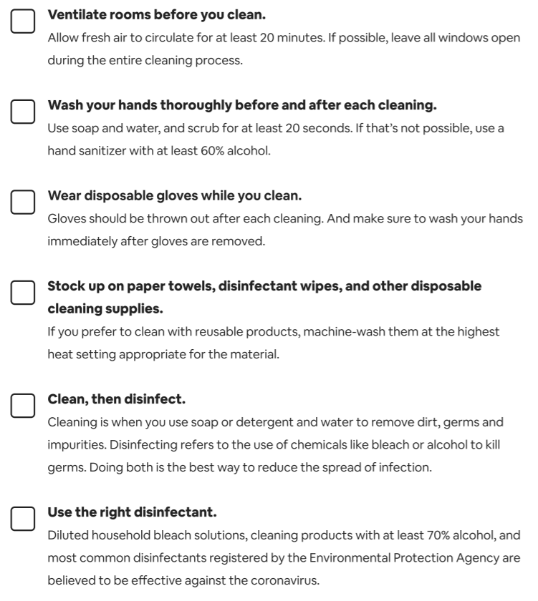

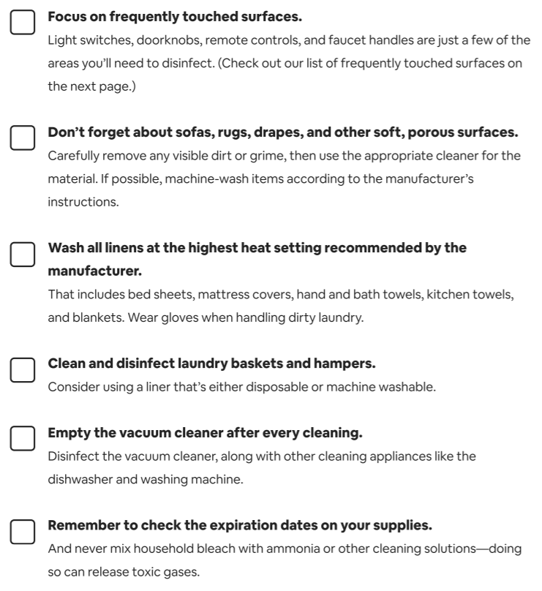

Special Note:
- Sinks could be an infection source and guests should avoid placing toothbrushes directly on counter surface. Use of each bathroom should be limited to one family only.
- Cleaning upon departure:
  - In general. Members should be extremely diligent in cleaning the cabin prior to departure.
  - Use ample quantities of cleaning products on all surfaces prior to departure.
  - If members do not use their own sheets and towels, dirty linens must be washed in hot water and thoroughly dried.
  - In the event members do not feel they are able to clean to standards outlined in this document, professional cleaning services will be provided for a fee not to exceed $150.
Relevant links:
Placer County – Covid 19 Update:
https://www.placer.ca.gov/DocumentCenter/View/43177/FULL-COVID19-GUIDANCE-FINAL-031720?bidId=
North Lake Tahoe Covid Update:
https://www.gotahoenorth.com/covid-19/
Lake Tahoe – “Know before you go” guide: This is a very good overview of what to expect and how to prepare for traveling to North Lake Tahoe.
https://www.gotahoenorth.com/wp-content/uploads/2020/06/NLT-Visitor-Readiness-Guide_v8.pdf
Covid 19 – Cal Osha Guidance (June 5, 2020):
https://covid19.ca.gov/pdf/guidance-hotels-lodging-rentals.pdf
Hotel & Lodging Guidance & Checklists
https://covid19.ca.gov/pdf/guidance-hotels.pdf
Placer County Reopening Requirements
https://www.placer.ca.gov/6582/Business-Checklists

General Tips – Responsible Travel & Tourism (Lake Tahoe)
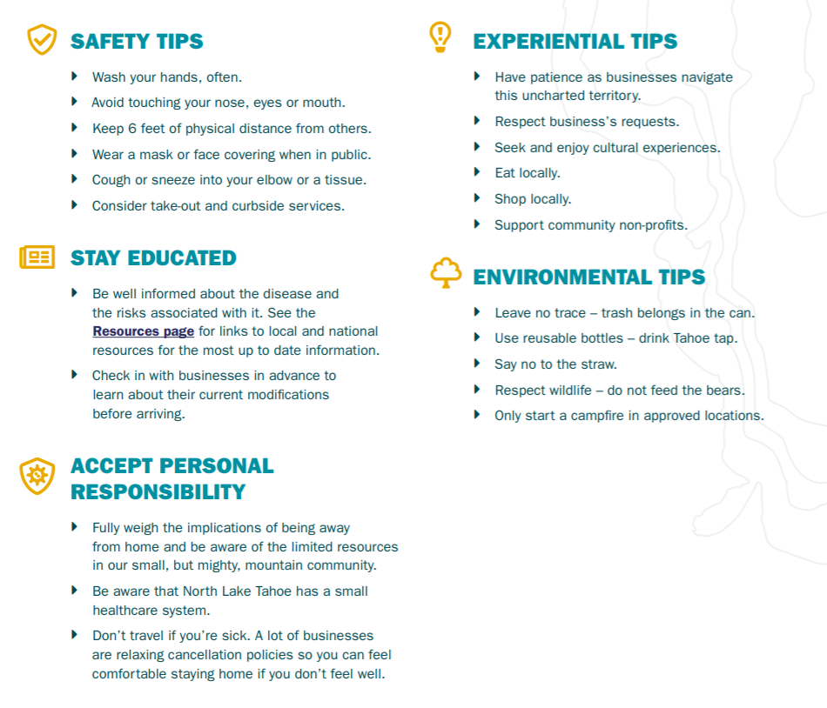
Helpful Hints: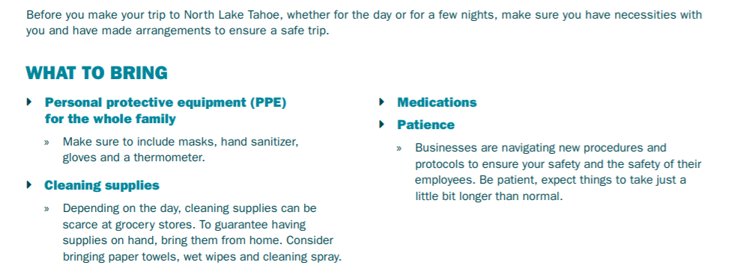

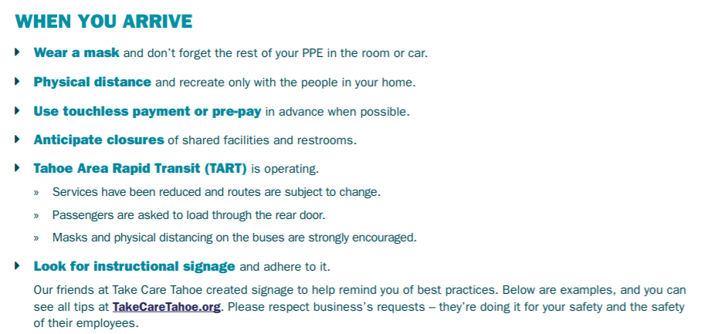
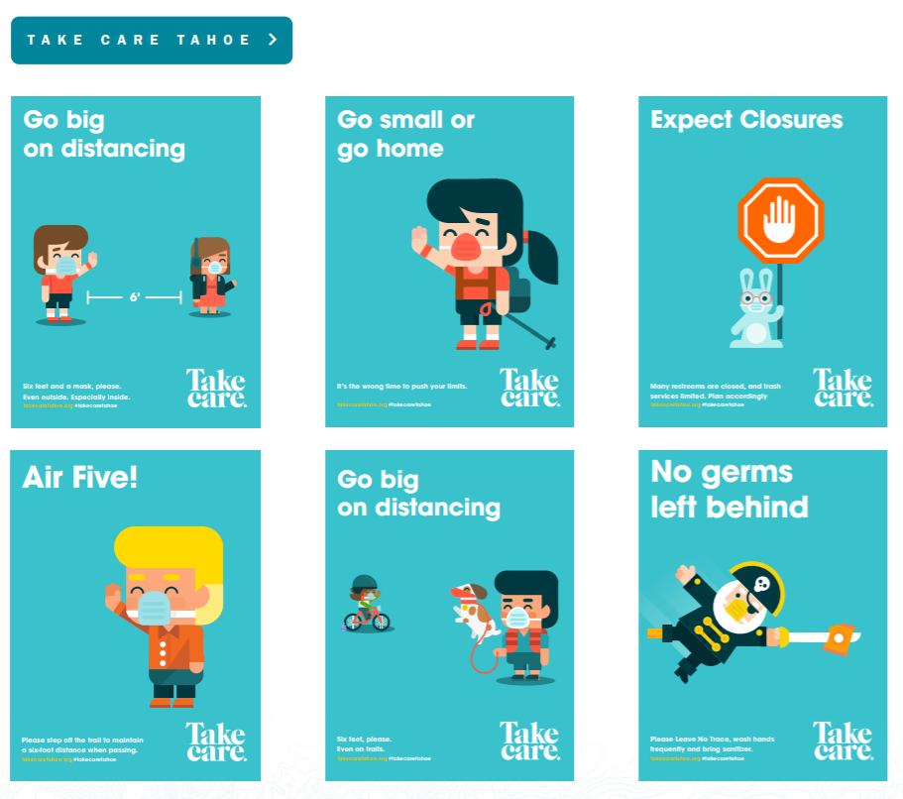
Industry Specific Tips: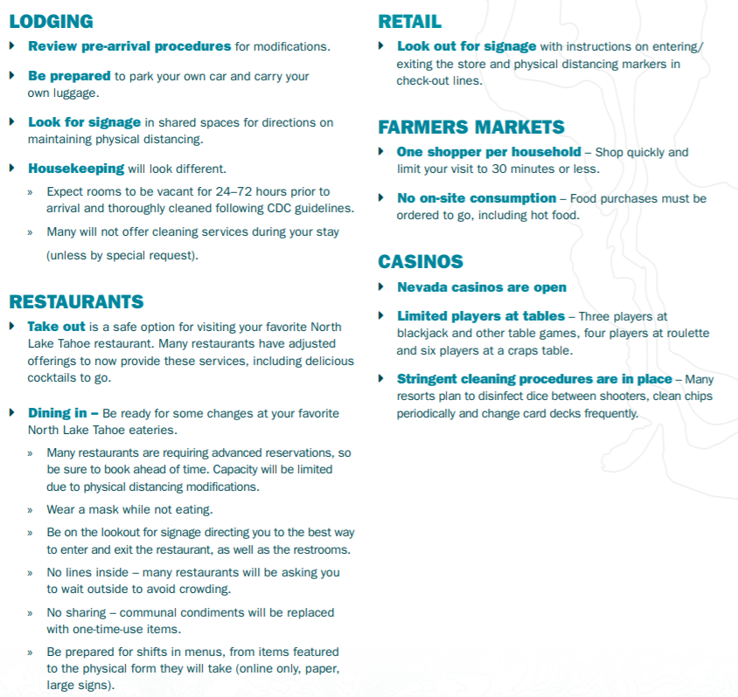

Outdoor Recreation
